module ROM_v1 (cs, addrb, datab, read_en);

input [2:0] addrb;
output [7:0] datab;
input read_en, cs;

reg [7:0] datab;

always @ (addrb)
if (read_en & cs)
case (addrb)
0: datab = 21;
1: datab = 255;
2: datab = 33;
3: datab = 99;
4: datab = 127;
5: datab = 13;
6: datab = 10;
7: datab = 88;
endcase
else
datab = 8'bz;

endmodule

module tst_ROM_v1;

reg [2:0] addrb;
wire [7:0] datab;
reg read_en, cs;

ROM_v1 rom1 (cs, addrb, datab, read_en);

initial begin
#0 addrb = 2;
#10 addrb = 5;
#10 addrb = 3;
#5 addrb = 7;
end
initial begin
#3 cs <= 1;
end
initial begin
#3 read_en <= 1;
end

endmodule

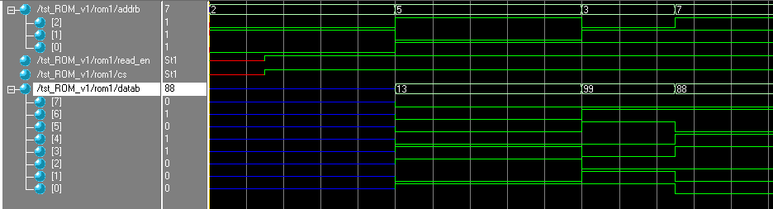

module ROM_v2 (cs, addrb, datab, read_en);

input [2:0] addrb;
output [7:0] datab;
input read_en, cs;

reg [7:0] datab;

always @ (*)
if (read_en & cs)
case (addrb)
0: datab = 21;
1: datab = 255;
2: datab = 33;
3: datab = 99;
4: datab = 127;
5: datab = 13;
6: datab = 10;
7: datab = 88;
endcase
else
datab = 8'bz;

endmodule

module tst_ROM_v2;

reg [2:0] addrb;
wire [7:0] datab;
reg read_en, cs;

ROM_v2 rom1 (cs, addrb, datab, read_en);

initial begin
#0 addrb = 2;
#10 addrb = 5;
#10 addrb = 3;
#5 addrb = 7;
end
initial begin
#3 cs <= 1;
end
initial begin
#3 read_en <= 1;
end

endmodule

